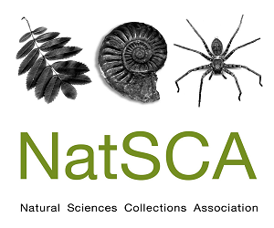
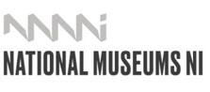

Collaborating and Connecting with Natural History
The Annual Conference & AGM of the Natural Sciences Collections Association (NatSCA) will be held on Thursday 14th and Friday 15th May 2026 at The Ulster Museum in Belfast, Northern Ireland.
Natural history collections are involved in a huge range of work that creates partnerships and fosters collaborations – this is a conference to share these stories. The NatSCA 2026 conference invites proposals for presentations looking at impact: how we work in partnership, including for example, with our community partners, NGOs, industry or communities of origin; how our work is making a difference; how we generate enthusiasm; and how we advocate for collections in a rapidly changing world. We are also interested in learning how our community can reconnect and recharge in the modern world.
We are interested in practical lessons, unique solutions, new collaborations, and to show what has and hasn’t worked. We are particularly looking for presentations that share the differences museums are making by using collections and programmes in:
- facing global challenges such as the biodiversity and climate crises, and environmental issues
- improving people’s lives, both within the museum community and without
- collaborations with external partners
- changing laws
- social justice, restitution, and addressing colonial legacies
We will prioritise papers that focus on sharing ideas, tools, and guidance rather than simply reporting results. We want to make this conference practical and useful, so please try to reflect this in your abstract.
While we have a focus on people that work with natural science collections, we recognise that we can learn from researchers and others in the wider museum sector. We welcome submissions from anyone who wishes to share techniques and ideas with broader relevance and application.
Papers can be presented as: A 20-minute presentation (consisting of a 15-minute talk followed by 5 minutes of Q&A), a 5-minute lightning talk, or a poster stand. Talks can be presented in person or by submission of a pre-recorded presentation, with the option of Q&A then being conducted over live video stream (Zoom).
Deadline for submission: 5pm GMT Sunday 8th February

NatSCA Conference & AGM 2026
CALL FOR PAPERS

Name:
Organisation:
Contact details:
Social media (only add if you are willing for these details to be shared):
Presentation Format: please circle or highlight your choice
20- Minute Presentation- In-Person or Pre-Recorded
5- Minute Lighting Talk- In-Person or Pre-Recorded
Poster Presentation- In-Person
Title:
Abstract (200 - 300 words):

For in-person presentations, the conference fee for the day of your talk will be waived. You may claim travel and accommodation expenses of up to £150 following submission of a write-up of your paper to either the NatSCA Blog, the Journal of Natural Science Collections or NatSCA Notes & Comments, as appropriate. You must also present receipts to the Treasurer. Both the paper and the receipts must be submitted by 31st July 2026.
For co–delivered talks only one speaker is eligible for the free place at the conference and expenses reimbursement. Travel bursary information can be found at: https://www.natsca.org/awards-and-bursaries

Deadline for abstracts is: 5pm GMT Sunday 8th February
Please submit your completed form to: conference@natsca.org

