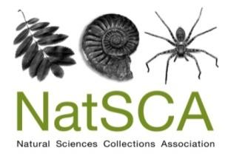
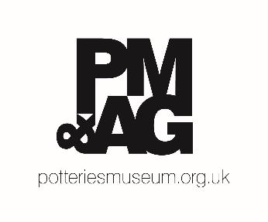

NatSCA Conference & AGM 2023
SAVE THE DATE & CALL FOR PAPERS

The Annual Conference & AGM of the Natural Sciences Collections Association will be held on Thursday 27th and Friday 28th April 2023. Stoke-on-Trent Museums will be hosting the conference at The Potteries Museum & Art Gallery. The first day will include the AGM, presentations and poster sessions. The second day will include presentations in the morning session, followed by gallery and collection tours in the afternoon.

So how do we actually do all this?
Hopeful futures and turning theory into practice for big issues in natural history collections

This is the “How To…” conference for people working with natural history collections. The last few years have seen unprecedented changes in the expectations for what the museum sector can deliver. Global and local social and environmental issues have coincided to reinforce the needs of museums to consider their reinvention and relevance.
These have brought many opportunities for exciting developments, but as we work to take positive action for and with our audiences – often centred on wellbeing – the people working and volunteering in the sector have been placed under pressures that impact their own wellness, making clear we need to support each other and look after ourselves too.
The #NatSCA2023 conference invites proposals for presentations on a broad range of themes that will spin hope from these subjects. We seek ideas from the natural history collections community and beyond, with the aim that we will come away feeling better. For example, have you developed practices or concepts that relate to:
- Supporting worker wellbeing?
- Engaging audiences with the climate and biodiversity crises?
- Work towards social justice, restitution and decolonisation with collections and audiences?
- The cost-of-living crisis?
We would like to hear from anyone and everyone who uses natural science collections to interact with important global topics.
This conference intends to offer an opportunity to share the best ideas and approaches to working with collections and audiences. We will prioritise papers that focus on sharing ideas, tools and guidance rather than simply reporting results – so please try to reflect this in your abstract. You may even consider beginning your presentation title with “How to…”
While we have a focus on natural science collections, we recognise that we can learn from others in the wider museum sector and we welcome submissions from anyone who wishes to share techniques and ideas with broader relevance and application.
Papers can be presented in any of several formats: A 20 minute presentation (consisting of a 15 minute talk followed by 5 minutes of Q&A), a 5 minute lightning talk or a poster stand. Talks can be presented in person or by submission of a pre-recorded presentation, with the option of Q&A then being conducted over live video stream (Zoom).

Please complete your abstract using the form below.

Deadline for submission: 5pm GMT Monday 6th February
Please send your abstract to: conference@natsca.org
NatSCA Conference & AGM 2023 CALL FOR PAPERS

Name:
Organisation:
Contact details:
Social media (only add if you are willing for these details to be shared):
Presentation Format (select as appropriate):
20 Minute Presentation (In-Person / Pre-Recorded)
5 Minute Lighting Talk (In-Person / Pre-Recorded)
Poster
If we are oversubscribed, would you be willing to submit your paper as a poster? (Please indicate as appropriate): Yes / No
Title:
Abstract (200 - 300 words):

For in-person presentations, the conference fee for the day of your talk will be waived. You may claim travel and accommodation expenses of up to £150 following submission of a write-up of your paper to the NatSCA Editor in a suitable format for either the Journal of Natural Science Collections or NatSCA Notes & Comments, as appropriate. You must also present receipts to the Treasurer. Both the paper and the receipts must be submitted by 31st July 2023.
For co–delivered talks only one speaker is eligible for the free place at the conference and expenses reimbursement.

Unfortunately, expenses are not available for poster presentations.

Deadline for submission: 5pm GMT Monday 6th February
Please send your abstract to: conference@natsca.org

