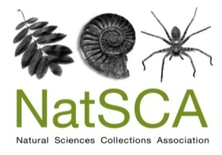
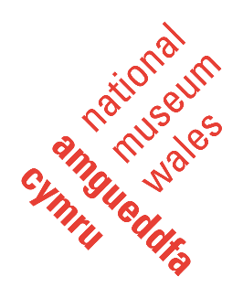

NatSCA Conference & AGM 2020 CALL FOR PAPERS

The Annual Conference & AGM of the Natural Sciences Collections Association will be held on Thursday 14th and Friday 15th May 2020. National Museum Wales will be hosting the conference at National Museum Cardiff. The first day will include the AGM, presentations and poster sessions. The second day will include presentations in the morning session, followed by collection tours in the afternoon.

Changing the World: Environmental Breakdown, Decolonisation and Natural Science collections

The #NatSCA2020 conference invites proposals for presentations exploring the role of natural science collections in addressing or engaging with ‘big issue’ challenges, both in the environment and in society. For example:
- Have you been involved in a research project using natural science collections to inform decision/policy makers on the implications of climate change, biodiversity loss or biosecurity threats?
- Are you developing plans to reconceptualise and decolonise your collections?
We would like to hear from anyone and everyone who uses natural science collections to interact with important global topics.
This conference intends to offer an opportunity to share the best ideas and approaches to working with collections. We will prioritise papers that focus on sharing ideas, tools and guidance rather than simply reporting results – so please try to reflect this in your abstract.
While we have a focus on natural science collections, we recognise that we can learn from others in the wider museum sector and we welcome submissions from anyone who wishes to share techniques and ideas with broader relevance and application.

Please complete your abstract using the form below.

Deadline for submission: 21st February 2020
Please send your abstract to: conference@natsca.org
NatSCA Conference & AGM 2020 CALL FOR PAPERS

Name:
Organisation:
Contact details:
Social media (only add if you are willing for these details to be shared):
Presentation or Poster (select as appropriate): Presentation / Poster
If we are oversubscribed, would you be willing to submit your paper as a poster? (Please indicate as appropriate): Yes / No
Title:
Abstract (200 - 300 words):

For presentations, the conference fee for the day of your talk will be waived. You may claim travel and accommodation expenses of up to £100 following submission of a write-up of your paper to the NatSCA Editor in a suitable format for either the Journal of Natural Science Collections or NatSCA Notes & Comments, as appropriate. You must also present receipts to the Treasurer. Both the paper and the receipts must be submitted by 31st July 2020.
For co–delivered talks only one speaker is eligible for the free place at the conference and expenses reimbursement.

Unfortunately, expenses are not available for poster presentations.

Deadline for submission: 21st February 2020
Please send your abstract to: conference@natsca.org

