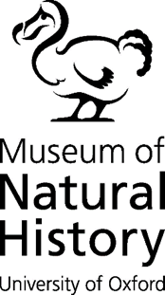
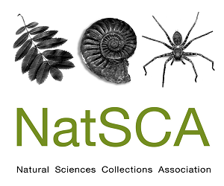
Bursaries for NatSCA 2024 Conference Oxford

NatSCA offers a number of bursaries for members towards the cost of attending the conference in person and online. The Committee has decided the simplest way to disburse funds is to waive the conference fee for online attendance and bursaries up to £250 for in person attendance.

These sums may be set against your;
- travel costs (in-person attendance)
- accommodation costs (in-person attendance)

Re-imbursement will be made against receipts, and delivery of your article for the journal – see conditions below. We hope this allows for variable institutional practices in paying for conferences – some places will pay fees but not expenses, others the opposite.

Conditions:

- Only members of the Natural Science Collections Association can apply for a bursary.

- Bursaries are limited to one per person per year.

- All successful applicants must provide a write up for the NatSCA blog before the bursary can be paid. The topic of the blog post can be discussed with the Editor.
- Travel costs to be agreed with the Bursary Committee at the earliest possible date.
- International applications will be considered at the discretion of the Committee.

- In the case of competition, preference will be given to people who have not received a bursary previously.
- Bursaries are only open to individual members. Institutional members cannot apply.

ALL bursaries are given at the discretion of the Committee and require proof of payment.

To apply, please complete the form below and return to: to bursaries@natsca.org
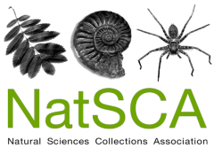

Bursary application form

Name:
Address:
e-mail:
Date and details of conference or training event applying for support for:
How would this bursary help you support natural science collections?
(100 words max)
How much are you applying for? Please give detailed breakdown.

Please return to: bursaries@natsca.org

