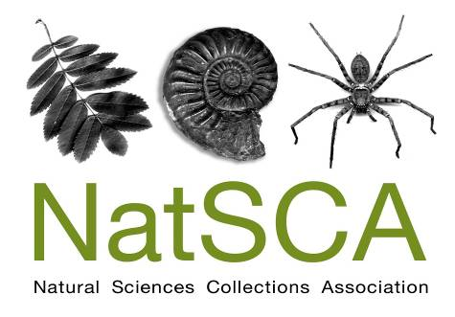
Registered charity 1098156
Taxidermy: curation, care, context & creativity
Conference to explore the care, curation, ethics and use of taxidermy collections.

BOOKING FORM

9.30am - 4pm Friday 18th July 2014

Chandler House (UCL, Room G10), 2 Wakefield Street, London, WC1N 1PF

Please complete this booking form and send to Holly Morgenroth address below.

Please keep a copy of your form for reference.

DELEGATE DETAILS:

Name(s):

Organisation:

Address:

E-mail:

Tel:

SEMINAR COSTS:

 | Cost per delegate | Number of delegates | Total cost
Member* | £20
Non-member** | £35
 |  | TOTAL

* Please note that two member rate places are permitted at each workshop for institutional members.

** For just £15 you can become a NatSCA member and enjoy member rate places at our conferences and workshops as well as receiving our annual journal. Contact membership@natsca.org for information, or join online at http://natsca.org/membership

NOTE: Places for this meeting are limited and priority is given to those booking using Eventbrite. A small quota of tickets has been reserved for those booking using this form, so please return it ASAP (by 4th July at the latest). The reserved offline ticket quota will be made available online from 7th July 2014
Please complete the payment section of the form as FULLY and ACCURATELY as possible

Please answer ‘yes’ where appropriate.

Delegate Names:

Who will be paying for this course?

Myself

My institution

Don’t know yet

I will be paying
I have enclosed a cheque with this form
I have already sent payment by bank transfer
Please send an invoice for the amount above
Please issue a receipt

Institutional Payment
My institution will pay by cheque or bank transfer
Please send an invoice for the amount above
Please issue a receipt
*Name of institution paying
*Invoice made out to
*Invoice sent by post or email to
*e.g. for myself at RAMM I would complete as:
Exeter City Council
Exeter City Council, Civic Centre, Paris Street, Exeter, Devon, EX1 1JN
Holly.Morgenroth@exeter.gov.uk

Online Payment

You can pay for this event online through Eventbrite by following this link:

http://www.natsca.org/event/taxidermy-conference-2014

Cheques

Please make cheques payable to the ‘Natural Sciences Collections Association’

BACS payments

Please quote the invoice number with all transfers. If an invoice is yet to be issued the delegate’s name must be quoted.

Bank – HSBC
Branch – Hereford High Town Branch, 35, High Town, Hereford, HR1 2AQ
Sort Code – 40-24-11
Account no. – 91645722
Account name – Natural Sciences Collections Association

Please send booking forms and payments to:
Holly Morgenroth: 3 Abbey Road, Exeter, Devon, EX4 7BG. holly.morgenroth@exeter.gov.uk

