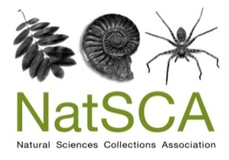
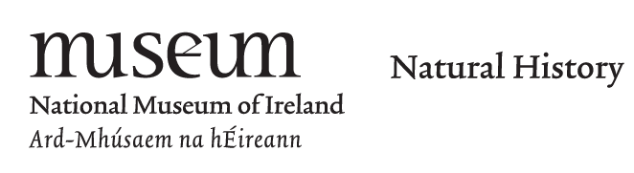

NatSCA Conference & AGM 2019 CALL FOR PAPERS

The Annual Conference & AGM of the Natural Sciences Collections Association will be held between the 1st and 3rd May 2019 at the National Museum of Ireland, Dublin – Collins Barracks site. The afternoon of the first day will include tours and activities, the second day will include the AGM, presentations and poster sessions, and the third day will include presentations and tours.

Dead Interesting: Secrets of Collections Success

The #NatSCA2019 conference aims to unlock the secrets of collections success by sharing how our members and colleagues in the wider sector have used collections to benefit their organisations, communities and the wider world.

We will host three themed sessions, with a focus on:

Collections: Reveal your collections care, research and access secrets.

Engagement: What are your engagement success stories and how did you make them happen?

Museums and Tech: How has technology helped you unlock, understand and unleash your collections?

This conference intends to offer an opportunity to share the best ideas and approaches to working with collections. We will prioritise papers that focus on sharing ideas, tools and guidance rather than simply reporting results – so please try to reflect this in your abstract.

While we have a focus on natural science collections, we recognise that we can learn from others in the wider museum sector and we welcome submissions from anyone who wishes to share techniques and ideas with broader relevance and application.

Please complete your abstract using the following form and note that if your paper is accepted your name, organisation and social media handle (but not your contact email) will be published online in the conference programme.

Deadline for submission: 4th January 2019
Please send your abstract to: conference@natsca.org
NatSCA Conference & AGM 2019 CALL FOR PAPERS

Name:
Organisation:
Social media (optional):
Contact email:
Session (select as appropriate): Collections / Engagement / Museums and Tech
Presentation or Poster (select as appropriate): Presentation / Poster
If we are oversubscribed, would you be willing to submit your paper as a poster? (Please indicate as appropriate): Yes / No
Title:
Abstract (200 - 300 words):

For presentations, the conference fee for the day of your talk will be waived. You may claim travel and accommodation expenses of up to £100 following submission of a write-up of your paper to the NatSCA Editor in a suitable format for either the Journal of Natural Science Collections or NatSCA Notes & Comments, as appropriate. You must also present receipts to the Treasurer. Both the paper and the receipts must be submitted by 20th July 2019 or claims will not be reimbursed.
For co–delivered talks only one speaker is eligible for the free place at the conference and expenses reimbursement.

Unfortunately, expenses are not available for poster presentations.

Deadline for submission: 4th January 2019
Please send your abstract to: conference@natsca.org

