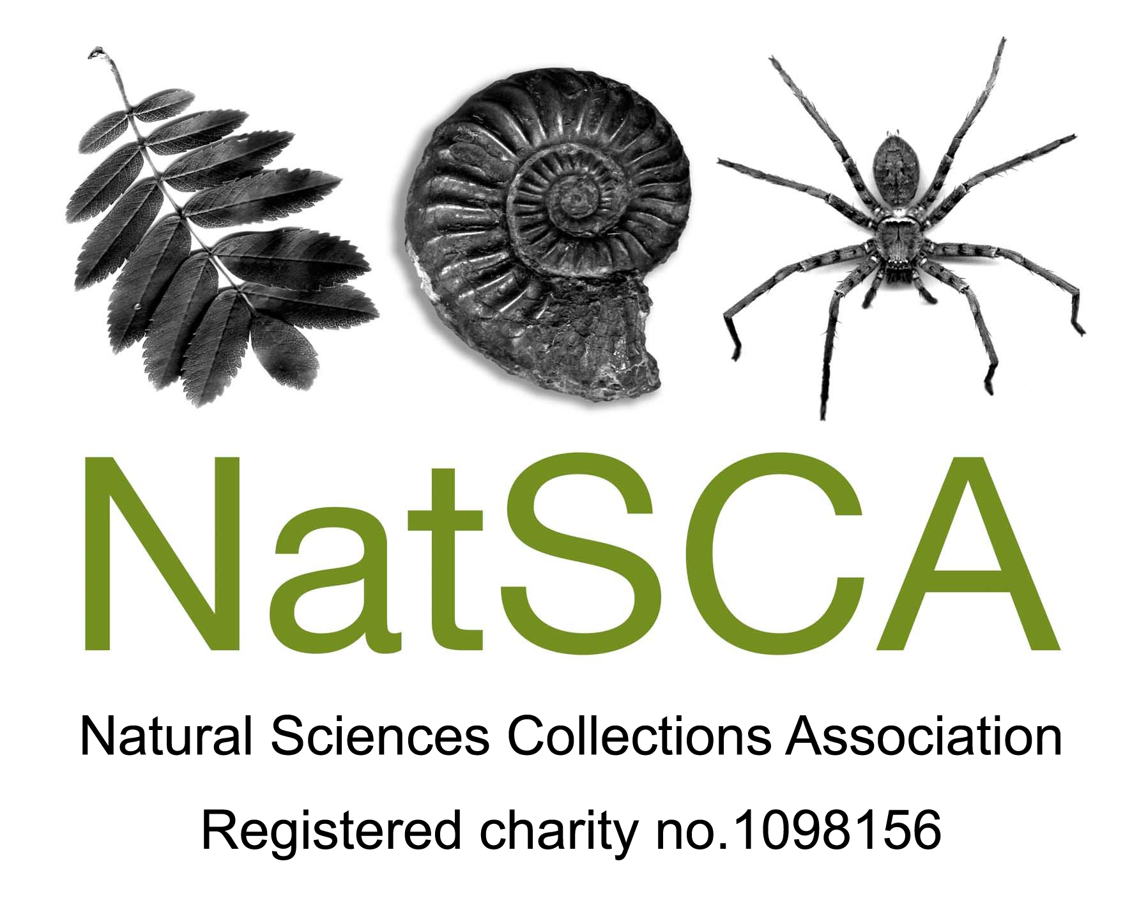
Evolving Ideas: provocative new ways of working with collections
AGM & Conference 20th & 21st April 2017

University Museum of Zoology, Cambridge

BOOKING FORM

CONFERENCE REGISTRATION COST:

NatSCA Members | Non-members* | Number of days
£85 | £125 | 2 | Early bird (before 10th March)
£100 | £140 | 2 | Late registration
£50 | £70 | 1 | Early bird (before 10th March)
£60 | £80 | 1 | Late registration

(Please note that two member rate places are permitted at conference for institutional members)

* For just £20 you can become a NatSCA member and enjoy member rate places at our conferences and workshops as well as receiving our annual journal and being eligible for bursaries. Contact membership@natsca.org for information or join online at http://natsca.org/membership

DELEGATE DETAILS (If using this form for multiple delegates, please attach additional details for each):

Name(s):

Organisation:

Address:

E-mail:

Tel:
Day attending: | Thurs 20th only □ Fri 21st only □ Both days □
Dietary information: | Vegetarian □ Vegan □ Gluten-free □
Are you a speaker? | IF YOU ARE SPEAKING PLEASE USE SPEAKER’S BOOKING FORM
Twitter username  (for use on delegate badge) | @

Do you give permission for your name, organisation and email address to appear on the delegate list? | Yes / No

 | Both days |  | Thursday only |  | Friday only |  | Total
 | Ticket price | No of delegates | Ticket price | No of delegates | Ticket price | No of delegates
EARLYBIRD Booked before 10th March 2017
EARLYBIRD Member* | £85 |  | £50 |  | £50
EARLYBIRD Non-member** | £125 |  | £70 |  | £70
Booked on or after 10th March 2017
Member* | £100 |  | £60 |  | £60
Non-member** | £140 |  | £80 |  | £80
 |  |  |  |  |  | Subtotal
Conference Meal (Thursday night)  NB please make it clear if you wish to be invoiced separately for the meal  This year delegates will be able to experience a traditional, time-honored Cambridge event. The conference dinner will be held in the magnificent 17th century Great Hall of Clare College. See our webpage for the menu: natsca.org/conference2017 |  |  |  |  | Price | No of attendees | Total
 |  |  |  |  | £35
 |  |  |  |  | Total including conference and meal
Please complete the payment section of the form as FULLY and ACCURATELY as possible

Delegate Names:

Who will be paying for this course? (Please tick)

Myself

My institution

Don’t know yet

I will be paying by
I have enclosed a cheque with this form
I have already sent payment by bank transfer
Please send an invoice for the amount above
Please issue a receipt

Institutional Payment
My institution will pay by cheque or bank transfer
Please send an invoice for the amount above
Please issue a receipt
*Name of institution paying
*Invoice made out to
*Invoice sent by post or email to

*e.g. for myself at RAMM I would complete as:
Exeter City Council
Exeter City Council, Civic Centre, Paris Street, Exeter, Devon, EX1 1JN
Holly.Morgenroth@exeter.gov.uk

Online Payment

You can pay for this event online through Eventbrite by following this link or following the link on our webpage: natsca.org/conference2017

Cheques

Please make cheques payable to the ‘Natural Sciences Collections Association’

BACS payments

Please quote the invoice number with all transfers. If an invoice is yet to be issued, the delegate’s name must be quoted.
Bank: HSBC
Branch: Hereford High Town Branch, 35, High Town, Hereford, HR1 2AQ
Sort Code: 40-24-11
Account no.: 91645722
Account name: Natural Sciences Collections Association

Please send completed booking forms to:

Holly Morgenroth, 3 Abbey Road, Exeter, Devon, EX4 7BG

Or email them to: treasurer@natsca.org

by 7 April 2017

Keep a copy of your form for reference

