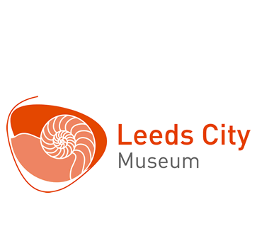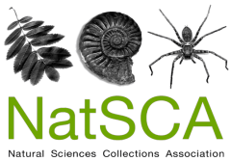

NatSCA Conference & AGM 2018 CALL FOR PAPERS
The Natural Science Collections Association will be holding their next annual conference & AGM on 26 and 27 April 2018 at Leeds City Museum.
The museum ecosystem: exploring how different subject specialisms can work closer together.

This conference aims to lead us outside our comfort zone and explore how working closely with different disciplines and departments can not only strengthen our own areas of expertise, but museums as a whole. The museum ecosystem is vast and not limited to just museums as it includes universities, local organisations, funding bodies, artists, communities and many other stakeholders.

What have you learned by working closely with colleagues in your museum that the rest of the museum sector would benefit from knowing?
Have you developed a way of collaborating with different collections areas to create an exciting project?
Can you share tips on working with community groups or artists to make your collections more relevant to your audiences?

The #NatSCA2018 conference theme is wide – we want two days of sharing and discussion about how we can ensure working together is better for all.

We are inviting you to propose presentations and posters that focus on sharing ideas, tips and mechanisms that will help inform the work of other attendees.

Proposals are welcome from colleagues across all disciplines (not just natural history!)

For more details about #NatSCA2018, visit natsca.org/natsca2018. To submit an abstract, please complete the form on the following page and submit to mailto:conference@natsca.org..

Deadline for submission: 2nd February 2018

Abstract for NatSCA Conference & AGM 2018

Name:
Organisation:
Contact details:
Abstract (100 - 150 words):

Would you prefer to offer your paper as a presentation or a poster? (Please indicate as appropriate)
Presentation / Poster

We often have more papers offered for presentations than we are able to accommodate. If your paper is not selected for a presentation, would you be willing to submit it as a poster? (Please indicate as appropriate):
Yes / No

Unfortunately, expenses are not available for poster presentations.
Expenses for attendance of speakers (up to £100) will be available with receipts and a write-up of their presentation for the NatSCA Blog, NatSCA Notes & Comments or the Journal of Natural Science Collections if submitted by 3rd August 2018.

Please send this form to conference@natsca.org

