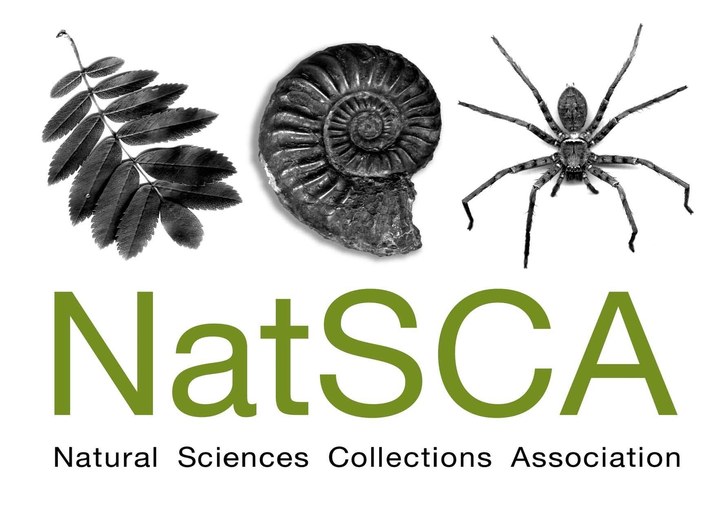
Bringing the Dead to Life:
how to display museum
natural science

Room G22 LT, Pearson Building (North East
Entrance), UCL, 22nd September 2017
Time | Speaker
9.30 – 10.00 | REGISTRATION
10.00 – 10.05 | WELCOME
10.05 – 10.35 | Kelly Richards (University Museum of Zoology, Cambridge)
10.35 – 11.05 | Jon Clatworthy (Lapworth Museum of Geology)
11.05 – 11.35 | Sophie Forgan (Captain Cook Memorial Museum)
11.35 – 11.55 | BREAK
11.55 – 12.25 | Raphael Chanay (Natural History Museum)
12.25 – 12.55 | Ebony Andrews (Calderdale Museums)
12.55 – 1.45 | BREAK
1.45 – 2.30 | Jan Freedman (Plymouth Museums)
2.30 – 2.50 | Euan’s Guide (disabled access reviews)
2.50 – 3.05 | BREAK
3.05 – 3.35 | Nick Marsden (Science Museum)
3.35 – 4.05 | Michelle Davis (Horniman Museum)
4.05 – 4.30 | BREAK/END
4.30 – 5.15 | Tour of Grant Museum of Zoology including new exhibition “The Museum of Ordinary Animals” (please book at registration, limited places)

Kelly Richards
University Museum of Zoology, Cambridge

Renovate! Innovate! Redisplaying zoological specimens at the University Museum of Zoology, Cambridge.
The University Museum of Zoology, Cambridge is reaching the end of a major project to redevelop the museum building, displays and adjoining research facilities. The redevelopment is an exciting opportunity to renovate and update the main displays in line with current scientific understanding and interpretation. While the former interpretive narrative and layout of the museum is maintained in the new designs, a number of new displays explore other themes that support the narrative.
Two such displays are the ‘Circle of life’ case and the ‘Insect ecology and evolution’ case. Together these cases pose redisplay challenges such as awkward case dimensions, specimen conservation and mounting requirements, specimen limitations, access issues and interpretation restrictions. These case studies detail two different approaches using input from public evaluation, academic curators, artists, AV designers and specialist mount-makers to produce two displays which serve to enrich the museum environment and visitor experience in different ways.

Jon Clatworthy
Lapworth Museum of Geology, Birmingham

The Lapworth Rocks
Redisplaying the Lapworth Museum of Geology and being shortlisted for ‘Museum of the Year.’ A transformational change from a traditional university departmental museum, to a bustling, innovative and outward facing museum, but still supporting teaching and research in the Higher Education sector.

Sophie Forgan
Captain Cook Memorial Museum, Whitby

Make it beautiful! Publishing catalogues on a shoestring
Publishing a catalogue creates a permanent record of an otherwise ephemeral display. However it can be ruinously expensive. The speaker reflects on the experience of a small independent museum producing catalogues for some of their temporary exhibitions.

Raphael Chanay
Natural History Museum, London

Temporary exhibitions and audiences at the Natural History Museum, London
This talk will explore the Natural History Museum's current approach in terms of audience and temporary exhibitions, looking at the Museum's current strategy and the challenges of engaging families and independent adults with natural sciences.

Ebony Andrews
Calderdale Museums

Taxing times?
How can taxidermy be used to address the big questions we face collectively today? And more broadly, what is the role of museum taxidermy for contemporary display purposes, if it still has one? Much to the frustration of the natural science curator, the tired old tropes of ‘dusty’, ‘serried ranks’, ‘imperial relics’, etc. still hold some currency in the popular imagination when it comes to taxidermy. Yet, interesting approaches to the display of taxidermy objects are increasingly occurring across the UK and further afield, - displays that are collaborative, experimental, reflexive, or simply use taxidermy in new or different ways. This presentation will historically locate the major ideological shifts that have taken place in the presentation and display of taxidermy in UK museums over the last century, before moving on to discuss contemporary cases studies, and speculate as to the future of taxidermy for museum display purposes. (Ebony Andrews is an independent researcher, artist and museum professional with an interest in the history and politics of the interpretation and display of ideas about nature and the natural world).

Jan Freedman
Plymouth Museums

Guide to great text
The labels and panels in displays are the main way for museums to bring an object to life. In this interactive session, we will look at good and bad examples of labels and how we can make a short bit of text more engaging for the visitor. We will also go through some top tips for great text for you to take back to your museum!

Euan’s Guide
Disabled access reviews

Access considerations in museums
Whether you’re designing a new museum exhibit or adapting an existing one, it’s important to consider how different audiences will engage with the story you’d like to tell. Access considerations cover everything from making your exhibit wheelchair accessible, to adding subtitles, audio description and opening your museum a little earlier. Euan’s Guide introduce some of the key things curators should consider when bringing a new exhibition to life!
Presented by Clare Brown on behalf of Euan’s Guide.

Nick Marsden
Science Museum Group

Corporate Partnerships: Developing mutually beneficial relationships
In this presentation, we will look at the methods organisations can use to go about finding and securing corporate partnerships with a focus on cultivating partners to develop long term, mutually beneficial relationships. We will also look at the motivations behind business wanting to partner with cultural organisations and discuss current sponsorship trends.

Michelle Davis
Horniman Museum, London

Curation of living displays in a museum setting
Living collections provide a unique opportunity for visitor engagement. However their management presents a number of specific challenges when compared to orthodox natural history museum collections. Curatorial oversight requires a broad range of knowledge which is required to successfully manage a thriving collection. This talk will cover some of the facets of our daily work at the Horniman Museum Aquarium as well as running the coral tank at the highly successful temporary exhibition Coral Reefs: Secret Cities of the Sea, at the Natural History Museum.

